Epsom & Ewell
6
v
FC Deportivo Galicia
Saturday, 19th October 2019 – 3.00 p.m.
Good afternoon and welcome to High Road for our latest Combined Counties League match against FC Deportivo Galicia. We welcome their players, supporters and the match officials and hope they have a safe journey home.

We last hosted our opponents back in April of last season when they defeated us by two goals to nil. However, we won both away matches last term; 3-0 in the League in September of 2018 and 4-2 in the Division One Cup Semi-Final in April. Neither side has started the season as well as they would have hoped and we need to start a good run if we are to retain any hopes of clinching a top four promotion spot.

We were last here on Saturday 28th September when Farnham Town beat us by two goals to nil but due to my absence, I have to recap on a 1-4 home defeat to AFC Hayes seven days previously and a 2-4 defeat to Sheerwater in the League Cup in that midweek. Since then we have had further away trips with Bedfont & Feltham knocking us out of the Division One Cup 3-1 on Tuesday 1st October and we followed that on the Saturday with a late equaliser in a 2-2 draw at Cove and then last Saturday, we were postponed at Chessington & Hook United. This will now be played on Tuesday 19th November. Reports from all the matches are in here and I’d like to thank George Holland and Steve Dyke for their contributions in my absence.

Going forward, we are next in action on Saturday 2nd November when we make a trip to the Elmbridge Sports Hub for a match with Walton & Hersham and we are back here seven days later for a match with Sandhurst Town.

Finally, our match at Sutton United Development in the First Round of the Surrey Premier Cup was originally advised for Monday 14th October, but the pitch at Gander Green Lane was then required for a Youth team and the match will be rearranged shortly so keep checking the website. This is also the case with next Saturday’s match against Kensington & Ealing Borough which has been postponed for a Chipstead FA Trophy match.

On another subject, most of the regular supporters will be aware that we were founded back in March of 1918, but what fewer of you will know is that we actually didn’t play our first competitive match until 100 years ago this month! Read more about this later on in the issue.

Finally, we wish to thank our recent match sponsors Philip Harris and Paul Marshall, both supporters of our club since they were very young. Many more matches can be sponsored, including today’s match so please get in touch. We also have the players available for sponsorship too now at £40. Details are provided later in the programme. Just ask!

Enjoy the game!

Rich

You can follow us on social media – just see the inside cover for details.

Cover photo

There are six famous faces on the cover today. All are relevant to football in this Borough, but how many do you recognise?
Answers later in the programme.

Cherry Red Records Combined Counties League
Division One Table 2019/20
incl Tuesday 15th October | P | W | D | L | F | A | Pts | GD | H | A

Jersey Bulls | 11 | 11 | 0 | 0 | 46 | 5 | 33 | +41 | 13/4 | 16/11
Farnham Town | 9 | 7 | 1 | 1 | 21 | 7 | 22 | +14 | 0-2 | 15/2
Sandhurst Town | 10 | 6 | 2 | 2 | 20 | 13 | 20 | +7 | 9/11 | 14/3
Tooting Bec | 8 | 5 | 3 | 0 | 23 | 11 | 18 | +12 | 2-2 | 12/11
Kensington & Ealing Boro | 11 | 6 | 0 | 5 | 27 | 23 | 18 | +4 | 26/10 | 4/1
Westside | 10 | 5 | 1 | 4 | 23 | 15 | 16 | +8 | 28/12 | 3-1
Dorking Wanderers Res | 11 | 5 | 1 | 5 | 29 | 23 | 16 | +6 | 23/11 | 11/4
Walton & Hersham | 8 | 5 | 1 | 2 | 19 | 13 | 16 | +6 | 31/3 | 2/11
British Airways | 11 | 4 | 3 | 4 | 19 | 23 | 15 | -4 | 11/1 | 29/2
AFC Hayes | 8 | 3 | 2 | 3 | 22 | 17 | 11 | +5 | 1-4 | 18/1
Bedfont & Feltham | 9 | 3 | 2 | 4 | 15 | 16 | 11 | -1 | 14/12 | 18/4
Epsom and Ewell | 9 | 3 | 2 | 4 | 19 | 21 | 11 | -2 | x | x
Cove | 10 | 3 | 2 | 5 | 17 | 31 | 11 | -14 | 25/1 | 2-2
FC Deportivo Galicia | 11 | 3 | 2 | 6 | 10 | 30 | 11 | -20 | 19/10 | 1/2
Chessington & Hook Utd | 9 | 3 | 3 | 3 | 13 | 14 | 9* | -1 | 22/2 | 19/11
Fleet Spurs | 9 | 3 | 0 | 6 | 16 | 21 | 9 | -5 | 3-5 | 7/12
Ash United | 10 | 3 | 0 | 7 | 17 | 28 | 9 | -11 | 8/2 | 2-1
Bagshot | 10 | 2 | 1 | 7 | 10 | 26 | 7 | -16 | 4/4 | 1-2
Eversley & California | 9 | 1 | 1 | 7 | 9 | 22 | 4 | -13 | 21/3 | 21/12
Godalming Town | 9 | 1 | 1 | 7 | 15 | 31 | 4 | -16 | 5-2 | 30/11
* Chessington & Hook United – 3 points deducted for playing an ineligible player on 3rd August v Godalming Town

Lucky Day? – 19th October
Played 16 - Won 7 Drawn 5 Lost 4 - For 41 Against 24 - PPG 1.63 - Above Average
Our Club record against FC Deportivo Galicia
Played 3 - Won 2 Drawn 0 Lost 1 - For 7 Against 4 - PPG 2.00 - Very Good
Our Largest wins and losses against FC Deportivo Galicia
22nd September 2018 - W 3-0 - Combined Counties League Division One (A)
16th April 2019 - L 0-2 - Combined Counties League Division One (H)
FC Deportivo Galicia‘s Last Visit
16th April 2019 – Lost 0-2 - Combined Counties League Division One

Latest Results and Fixtures
Combined Counties League – Wednesday 18th September
Westside | 4-2 | Dorking Wanderers Reserves
Combined Counties League – Saturday 21st September
Bagshot | 1-1 | Chessington & Hook United
Bedfont & Feltham | 0-0 | Sandhurst Town
Cove | 0-6 | Dorking Wanderers Reserves
Epsom & Ewell | 1-4 | AFC Hayes
Farnham Town | 1-1 | British Airways
Fleet Spurs | 2-4 | Tooting Bec
Godalming Town | 3-0 | FC Deportivo Galicia
Jersey Bulls | 5-1 | Eversley & California
Kensington & Ealing Borough | 2-1 | Ash United
Westside | 3-4 | Walton & Hersham
Combined Counties League Cup First Round – Tuesday 24th September
Egham Town | 0-2 | Raynes Park Vale
Eversley & California | 2-4 | Balham
Godalming Town | 0-4 | CB Hounslow United
Combined Counties League Cup Second Round – Tuesday 24th September
Ash United | 2-2+ - 4-1p | Bagshot
Cobham | 2-4 | Fleet Spurs
Farnham Town | 3-0 | Walton & Hersham
Frimley Green | 3-7+ | Ascot United
Molesey | 3-1 | Kensington & Ealing Borough
Sandhurst Town | 2-1 | Cove
Sheerwater | 4-2 | Epsom & Ewell
Combined Counties League Cup First Round – Weds 25th September
Colliers Wood United | 4-2 | British Airways
Guildford City | 2-3 | Hanworth Villa
Tooting Bec | 2-4 | Bedfont & Feltham
Combined Counties League Cup Second Round – Weds 25th September
Westside | 2-1 | Southall
Combined Counties League – Saturday 28th September
AFC Hayes | 1-2 | Jersey Bulls
Ash United | 4-1 | Bedfont & Feltham
British Airways | 0-3 | Westside
Chessington & Hook United | 1-1 | Eversley & California
Dorking Wanderers Reserves | 1-0 | Bagshot
Latest Results and Fixtures
Combined Counties League – Saturday 28th September
Epsom & Ewell | 0-2 | Farnham Town
FC Deportivo Galicia | 0-3 | Walton & Hersham
Fleet Spurs | 1-2 | Kensington & Ealing Borough
Sandhurst Town | 2-1 | Godalming Town
Tooting Bec | 4-1 | Cove
Combined Counties League Cup First Round – Tuesday 1st October
Badshot Lea | 3-1 | Redhill
Esoteric Division One Cup – First Round – Tuesday 1st October
Ash United | 1-5 | British Airways
Bedfont & Feltham | 3-1 | Epsom & Ewell
Kensington & Ealing Borough | 3-2 | Tooting Bec
Combined Counties League – Saturday 5th October
Bagshot | 1-4 | AFC Hayes
Bedfont & Feltham | 3-4 | Dorking Wanderers Reserves
Cove | 2-2 | Epsom & Ewell
Eversley & California | 2-3 | British Airways
FC Deportivo Galicia | 1-0 | Ash United
Fleet Spurs | 1-2 | Chessington & Hook United
Godalming Town | 1-5 | Tooting Bec
Jersey Bulls | 4-1 | Sandhurst Town
Walton & Hersham | 0-1 | Farnham Town
Westside | 2-1 | Kensington & Ealing Borough
Esoteric Division One Cup – First Round – Tuesday 8th October
Bagshot | 1-4 | Walton & Hersham
Combined Counties League – Saturday 12th October
British Airways | 0-4 | Jersey Bulls
Chessington & Hook Utd | p-p | Epsom & Ewell
Eversley & California | p-p | Godalming Town
Farnham Town | 2-0 | Dorking Wanderers Reserves
FC Deportivo Galicia | 4-3 | Cove
Kensington & Ealing Borough | 1-1 | Bagshot
Tooting Bec | 2-1 | Fleet Spurs
Walton & Hersham | 5-1 | Ash United
Esoteric Division One Cup – Second Round – Tuesday 15th October
Kensington & Ealing Borough | V | Eversley & California
Latest Results and Fixtures
Combined Counties League – Tuesday 15th October
Ash United | p-p for Westside  FA Vase match | Westside
Combined Counties League – Saturday 19th October
Bagshot | V | British Airways
Bedfont & Feltham | V | Kensington & Ealing Borough
Cove | V | Eversley & California
Epsom & Ewell | V | FC Deportivo Galicia
Combined Counties League – Saturday 19th October
Fleet Spurs | V | Farnham Town
Godalming Town | V | Ash United
Jersey Bulls | V | Walton & Hersham
Sandhurst Town | V | Dorking Wanderers Reserves
Tooting Bec | V | Chessington & Hook United
Westside | V | AFC Hayes
Esoteric Division One Cup – Second Round – Tuesday 22nd October
Cove | V | FC Deportivo Galicia
Dorking Wanderers Reserves | V | Jersey Bulls
Fleet Spurs | V | Westside
Godalming Town | V | Farnham Town
Sandhurst Town | V | Chessington & Hook United
Esoteric Division One Cup – Second Round – Wednesday 23rd October
British Airways | V | Bedfont & Feltham
Combined Counties League – Saturday 26th October
AFC Hayes | V | Godalming Town
Ash United | V | Fleet Spurs
British Airways | V | Walton & Hersham
Chessington & Hook United | V | Jersey Bulls
Cove | V | Westside
Dorking Wanderers Reserves | V | Tooting Bec
Epsom & Ewell | p-p | Kensington & Ealing Borough
Eversley & California | V | Bedfont & Feltham
Farnham Town | V | FC Deportivo Galicia
Sandhurst Town | V | Bagshot
Combined Counties League – Saturday 2nd November
Walton & Hersham | V | Epsom & Ewell

From behind the goal
Epsom & Ewell 1-4 AFC Hayes
Combined Counties League Division One - Saturday 21st September 2019
Report by George Holland

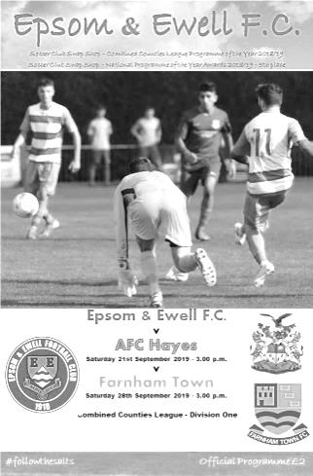
The Salts went into this match having won a midweek friendly 4-2 on Wednesday evening at Horsham's new ground against Horsham Under 23's. However, the Salts were second best in this match, having been completely outfought in every sense of the word by AFC Hayes on Saturday.

The warning signs were there after only three minutes when a shot crashed against the Salts' crossbar, followed up by a shot against the post, with the ball rolling across the 6 yard box. Felix Davies then gathered the ball, only to give it away again, to see a shot roll past the post.

AFC Hayes took only another four minutes to take a 1-0 lead. The ball came forward from midfield and Trey Pender-Brown struck a shot across Davies into the far corner of the net.

The Salts were struggling to get into the match, such was the dominance of their opponents and the lead became 2-0 on 15 minutes when Jack Smith was tripped just inside the Salts' area, and he despatched the resulting penalty past the despairing dive of Davies.

The Salts survived two further raids on their goal before Bobby Bennett had their first effort on target, when he unleashed a stinging low drive at goal, which Tom Clark saved for a corner which was easily dealt with on 30 minutes.

Although the Salts were by now trying to create more chances, the match oscillated both ways, with no further goals in the first half. So we reached the break at 0-2.

Jordan Gallagher had a great chance to reduce the arrears on 55 minutes when he received a through ball, chipped the ball over the keeper, but unfortunately a defender raced back to snuff out the danger and clear the ball away. Four minutes later Liam Roberts sprang the offside trap down the right wing, however his low cross was scrambled away by a defender in the box.

Nathan Dennis then trebled the score on 67 minutes when he took advantage of poor defending, running onto a pass, and shooting home for 0-3. It became 0-4 on 83 minutes with more slack defending, and Jordan Ellis raced forward to blast his shot home with ease.

Rob Hendry had a great chance, under pressure from a defender, on 85 minutes. However, instead of shooting when he could, he delayed his shot, but won a free kick in the process. The free kick went wide, and the chance was wasted. Going into injury time, Bobby Bennett's low hard drive was saved, went out for a throw on, but it was then cleared away on 92 minutes.

In the fifth minute of injury time Bennett was fouled by the corner flag. His opponent took exception to Bennett's minor shove back on him, which resulted in most of the other players having a major scuffle. The Referee eventually restored order, with a few bookings dished out to a few players. Bennett's eventual free kick was headed home into the far corner of the net by Lloyd Connelly, who rose highest, unchallenged on 95 minutes, to make the final score, 1-4 to AFC Hayes.

Epsom & Ewell: Felix Davies, Louis Chin, Joe Bonass-Ward, Jake Robinson, Todd Murphy,
Lloyd Connelly, Jordan Gallagher, Scott Murphy (c), Bobby Bennett, Toby Funnell, Liam Roberts

Subs: Zak Nightingale for Gallagher (60), Sean White for T.Murphy (65),
Rob Hendry for Funnell (73)

EL Records Division One Challenge Cup Draw
2018/19 Holders: Frimley Green
First Round
Kensington & Ealing Borough | 3-2 | Tooting Bec
Ash United | 1-5 | British Airways
Bedfont & Feltham | 3-1 | Epsom & Ewell
Bagshot | 1-4 | Walton & Hersham
Second Round
Dorking Wanderers Reserves | 22/10 | Jersey Bulls
Sandhurst Town | 22/10 | Chessington & Hook United
British Airways | 23/10 | Bedfont & Feltham
Godalming Town | 22/10 | Farnham Town
Cove | 22/10 | FC Deportivo Galicia
Fleet Spurs | 22/10 | Westside
Walton & Hersham | 22/10 | AFC Hayes
Kensington & Ealing Borough | 15/10 | Eversley & California

Surrey Premier Cup
2018/19 Holders: Lingfield
First Round
Bagshot | V | Horley Town Reserves
Met Police Reserves | V | Cobham Development
Godalming Town | 1-3 | Dorkinians
Sutton United Development | V | Epsom & Ewell
Reigatians | V | Chessington & Hook United
Carshalton Athletic U21 | V | Walton & Hersham
Old Wilsonians | V | Westfield Reserves
Ash United | V | AFC Croydon Athletic Development
FC Deportivo Galicia | v | Dorking Wanderers Reserves

From behind the goal
Sheerwater 4-2 Epsom & Ewell
Combined Counties League Cup – First Round - Tuesday 24th September 2019
Report by Steve Dyke

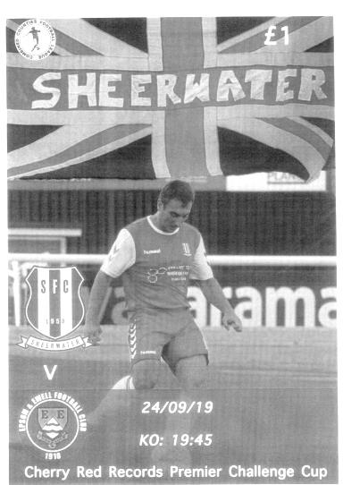
Epsom and Ewell exited the Cherry Red Combined Counties League cup at the first hurdle on Tuesday evening when despite an improved performance a lack of defensive concentration at the start of each half undid their efforts in other aspects of play.

Looking for a better performance than Saturday’s disappointment against AFC Hayes the Salts got off to the worst possible start. A free kick awarded to Sheerwater in the second minute was played to Josh Bowden unmarked who ran down the right hand side of the box to plant a shot past Felix Davies.

For the rest of the half we competed well and made several chances, Bobby Bennett was involved in most of them on the right wing and debutant centre forward Zak Nightingale showed up well with some good interplay and turns. In the 19th minute Jake Robinson had a powerful shot tipped over by Sheers keeper Stuart Norman.

The Epsom supporters went for their half time cuppa with hopes that their team would come back into the game in the second half. The hope lasted only to the 48th minute when a cross that really should have been cleared landed at the feet of Shane Rideout who fired home for 2-0.

The Salts were given a potential lifeline back into the game two minutes later when Nightingale made a powerful run into the box and was clipped by the defender alongside. Captain Scott Murphy scored a confident penalty to mark his 100th appearance.

On the hour mark we were undone again when the pacy Danny Taylor burst into the box to score a good goal. Further chances came and went for both sides when on 71 minutes Sheerwater sub Jimmy Norman was the only man in the box for a long swirling cross. He got to the header first which was saved by Davies bouncing back to Norman who stroked home the rebound.

Nightingale capped a promising first start for the club by reacting quickest to a header in the box to reduce the arrears in the 92nd minute. Sadly preventable goals let in earlier made it just a consolation.

Epsom and Ewell :- Felix Davies, Louis Chin, Joe Bonass-Ward, Jake Robinson,
Lloyd Connelly, Sean White, Bobby Bennett, Scott Murphy, Zak Nightingale,
Adam Heagney, Toby Funnell

Subs: Rob Hendry for White (74), Liam Roberts for Funnell (74),
Jordan Gallagher for Heagney (78)

EL Records Premier Challenge Cup
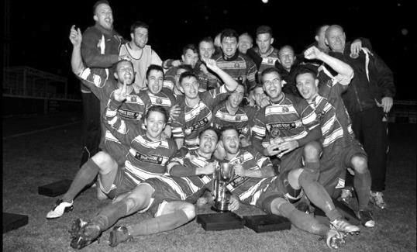
First Round
Guildford City | 2-3 | Hanworth Villa
Eversley & California | 2-4 | Balham
Tooting Bec | 2-4 | Bedfont & Feltham
FC Deportivo Galicia | 12/11 | AFC Hayes
Badshot Lea | 3-1+ | Redhill
Colliers Wood United | 4-2 | British Airways
Egham Town | 0-2 | Raynes Park Vale
Spelthorne Sports | 3/12 | Chessington & Hook United
Godalming Town | 0-4 | CB Hounslow United
Second Round
Ash United | 2-2 - 4-1p | Bagshot
Westside | 2-1 | Southall
Hanworth Villa | 12/11 | Jersey Bulls
Abbey Rangers | 19/11 | Raynes Park Vale
CB Hounslow United | 12/11 | Balham
Camberley Town | 12/11 | Colliers Wood United
Bedfont & Feltham | 12/11 | Knaphill
Frimley Green | 3-7+ | Ascot United
Sutton Common Rovers | V | 8
Sandhurst Town | 2-1 | Cove
Banstead Athletic | V | 4
Molesey | 3-1 | Kensington & Ealing Borough
Cobham | 2-4 | Fleet Spurs
Badshot Lea | 10/12 | Dorking Wanderers Reserves
Sheerwater | 4-2 | Epsom & Ewell
Farnham Town | 3-0 | Walton & Hersham

From behind the goal
Epsom & Ewell 0-2 Farnham Town
Combined Counties League Division One - Saturday 28th September 2019
Report by George Holland

We slipped to our third defeat in a week, having lost 4-1 at home to AFC Hayes the previous Saturday, and 4-2 to Sheerwater on Tuesday night in the CCL League Cup 2nd round.

Making his 50th appearance for the Salts, Bobby Bennett led by example after only 3 minutes, when he raced onto a pass and hit a superb shot on target. However, his wonderful effort was well saved by Dease Kerrison, and the danger was repelled.

Farnham came more into the match after this and created some dangerous looking raids with Epsom struggling to get their passing game going. On 28 minutes Epsom's goal led a charmed life when three efforts were somehow kept out. Firstly, a rasping drive rattled the crossbar, followed by a goal line clearance, and the follow up shot then going for a corner which Felix Davies dealt with and cleared upfield.

Two minutes later, Bennett had another trademark cracking drive well saved by Kerrison.

Scott Murphy then tried his luck when a foul 20 yards from goal saw Epsom gain a free kick. However, his effort struck the wall and out of play for a corner. From the corner, Farnham countered, and won a corner of their own. Epsom's defenders successfully defended the corner to start another attack of their own.

We reached the break with no score after Epsom had a couple more attacking moves which fizzled out.

Sean White strode forward on 51 minutes, but his rising drive was well saved by Kerrison. Following this Farnham started to dominate proceedings, and with Epsom giving the ball away too often, the warning signs were there. They capitalised on 65 minutes on one such error, and Jack May shot home with ease unchallenged to make it 1-0.

A rare foray upfield on 73 minutes resulted in Bennett being fouled in the box, while in race for the ball with a defender. Up stepped Scott Murphy only to blast his spot kick high over the bar. The chance to equalise and get back into the match had gone.

Six minutes later, Murphy gave the ball away on the edge of the area, and Oakley accepted the gift, and strode forward to blast home for his and Farnham's second goal.

The Farnham players were all appealing for a penalty on 82 minutes when a shot was deflected away for a corner by an Epsom defender in the area. The Referee waved away all their appeals. However, it has to be said that some of the decisions by the Referee's Assistant on the Stand side of the ground somewhat baffled both sets of fans.

With time running out, Epsom had a couple of tame efforts on goal, before the final whistle went for full time, and the score of 2-0 to Farnham.

With Epsom in 11th place in CCL1, there is a still a lot to play for with 4 promotion places up for grabs this season with the FA's restructuring of the Non League Pyramid.

Epsom and Ewell; Felix Davies, Louis Chin, Joe Bonass-Ward, Adam Heagney, Sean White, Lloyd Connelly, Bobby Bennett, Scott Murphy(c), Zak Nightingale, Toby Funnell, Rob Hendry.

Subs; Liam Roberts for Hendry (52), Jake Robinson for Adam Heagney (67)

First Eleven Appearances - (max 12)
Name | Debut | 2018/19 |  |  |  | Career Totals
 |  | App | Sub | Tot | Goals | App | Sub | Tot | Goals
BENNETT Bobby | 12/08/2018 | 7 | 3 | 10 | 3 | 48 | 3 | 51 | 26
BONASS-WARD Joe | 10/08/2019 | 10 | 0 | 10 | 0 | 10 | 0 | 10 | 0
CARNEY Billy | 12/01/2019 | 1 | 2 | 3 | 2 | 13 | 7 | 20 | 8
CARTON Kyle | 03/08/2019 | 2 | 0 | 2 | 0 | 2 | 0 | 2 | 0
CHIN Louis | 08/12/2018 | 6 | 1 | 7 | 0 | 19 | 2 | 21 | 0
CONNELLY Lloyd | 14/10/2017 | 11 | 0 | 11 | 2 | 89 | 4 | 93 | 8
DAVIES Felix | 03/08/2019 | 11 | 0 | 11 | 0 | 11 | 0 | 11 | 0
FUNNELL Toby | 03/08/2019 | 12 | 0 | 12 | 1 | 12 | 0 | 12 | 1
GALLAGHER Jordan | 07/08/2016 | 7 | 2 | 9 | 3 | 56 | 15 | 71 | 21
HEAGNEY Adam | 16/08/2016 | 9 | 0 | 9 | 1 | 123 | 13 | 136 | 4
HENDRY Rob | 08/08/2015 | 4 | 6 | 10 | 3 | 114 | 30 | 44 | 49
LEWIS Rory | 03/08/2019 | 1 | 1 | 2 | 0 | 1 | 1 | 2 | 0
MARTIN Chaz-Lee | 03/08/2019 | 5 | 0 | 5 | 2 | 5 | 0 | 5 | 2
MURPHY Scott | 20/01/2007 | 10 | 0 | 10 | 2 | 101 | 2 | 103 | 11
MURPHY Todd | 27/11/2018 | 4 | 0 | 4 | 0 | 7 | 9 | 16 | 0
NIGHTINGALE Zak | 03/08/2019 | 3 | 3 | 6 | 1 | 3 | 3 | 6 | 1
ROBERTS Liam | 12/08/2017 | 3 | 7 | 10 | 2 | 53 | 28 | 81 | 19
ROBINSON Jake | 23/02/2019 | 10 | 1 | 11 | 0 | 19 | 2 | 21 | 0
SMITH Taryn | 28/10/2017 | 7 | 1 | 8 | 1 | 21 | 12 | 33 | 6
SULLIVAN Ryan | 04/08/2018 | 1 | 0 | 1 | 0 | 31 | 2 | 33 | 0
THOMPSON Ashley | 21/08/2017 | 1 | 0 | 1 | 0 | 36 | 1 | 37 | 5
WHITE Sean | 02/08/2014 | 6 | 3 | 9 | 0 | 35 | 28 | 63 | 9
YOUNG Conor | 07/03/2015 | 1 | 0 | 1 | 0 | 62 | 0 | 62 | 0

From behind the goal
Bedfont & Feltham 3-1 Epsom & Ewell
League Division One Cup - First Round - Tuesday 1st October 2019

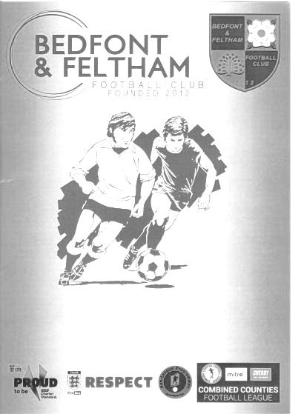
Fourth loss in a row as good run ends at the Orchard

On a torrentially wet and windy night which was bad enough to cause flight delays at nearby Heathrow Airport, the two teams took to a perfect playing surface and tried to play football in conditions which made it difficult to say the least. However, a lack of ideas up front, coupled with further defensive errors ensured that we would depart our third cup of the season at the first hurdle and now find ourselves in a very difficult situation after suffering four losses in a row.

This was our first loss against the reformed Bedfont & Feltham and we have seen some good results against them in the process; not least a 9-2 win here in 2016 and a 6-4 win only last April. It also looked as though we might continue that sequence as we started brightly in this match and Sean White thumped a post with a superb drive from 20 yards in just the sixth minute.

True to form though, within seconds we were hit on the counter attack and Felix Davies had to be down quickly to prevent the home side taking the lead. Then Toby Funnell, starting on the left wing in this match cut inside his man before shooting low but the keeper Chalupniczac was down smartly to prevent us taking the lead.

In the 19th minute we had a free kick and Adam Heagney delivered the ball into the danger area where Lloyd Connelly was first to reach it, but his shot lacked power and dribbled towards the goal. We paid for this almost immediately as in the 20th minute, a through ball was challenged for by two opposing players but the ball fell kindly to Kelly who had made the challenge in the first place and he beat Davies from 12 yards.

Now there are more than enough reasons why we have to look at ourselves for this loss but we certainly weren't helped by one of the worst refereeing decisions I have ever witnessed in nearly 40 years as a supporter. In the 27th minute, a ball was sent into the danger area from the left and as the Bedfont keeper came out to clear it, the ball held up in the wind and he instinctively knocked the ball away with his hand. Now, I can't confirm whether the incident was inside or outside the box, but it was a definite handball which the referee appeared to see, and when he then blew the whistle it was clear that their man was in trouble. Or so I thought!

Incredibly, having stopped our attack to penalise the home side, presumably with a red card for Chalupniczac, he then decided to speak with his assistant and after this, chose to award a drop ball instead!! At no point from the time he blew his whistle did the Assistant make the slightest indication to the referee that he had made a mistake and indeed had the referee not spoken to him, the home side would surely have been down to ten men, but once you have blown the whistle, then by definition he must have seen an offence, so to then change his mind was farcical

and represents the worst refereeing decision since we were penalised in 1997 for "penaltygate" when we encroached, but were denied a retake because the referee chose to award an indirect free kick against us for the encroachment!

This decision incensed our dugout and rightly so, and it is to our team's credit that with a complete lack of faith in the match official the players did not try to take the law into their own hands, but apart from a powerful low shot from Bobby Bennett that was well saved by the keeper who shouldn't have been on the field by then, we went off at the half trailing by the only goal.

Surely fired up by the injustice our players took the field for the second half looking to continue their superiority in possession, but a loss of the ball in midfield resulted in the ball being played out to their left wing where we were unable to cut out the low cross that was finished off by the ever alert Michael Capon in the 48th minute.

Rob Hendry entered the fray and nearly scored with his first intervention as his 20 yard strike was touched on by White but was well blocked by the keeper. Further substitutions followed as Taryn Smith and Jordan Gallagher both came on but we went 3-0 down in the 75th minute as we lost the ball not too far outside the area and it was was rifled back with interest powerfully beyond Davies who got a hand to it but couldn't keep it out, giving Kelly his second goal of the match.

In the 79th minute Bobby Bennett was bundled over in the penalty area and yet again the referee blew his whistle. Whilst admittedly it would have been a soft penalty, it looked like it was about to be given, but yet again the referee confused all people at the ground by merely indicating that it was a corner, which left most of us, me included, wondering why he felt the need to blow his whistle to signify a corner when the simple act of pointing there would have sufficed.

Gallagher picked up a yellow card for a bit of a lunge that originally the referee ignored, joining Jake Robinson in the book after a physical challenge a few minutes earlier, but both of these were probably both deserved cards on the night and we secured a faint consolation in the 87th minute when Hendry sent a clever pass through into the path of Gallagher who curled his low shot around the keeper to register his 21st goal in just 71 appearances.

However, it was too little, far too late and the whistle for full time blew a few minutes later. For me, this was a familiar story of a frustrating season where we had much of the ball but didn't hurt the opposition with it as attack after attack fizzled out with too much sideways passing followed by a hopeful punt up the field that in most case ran through to the keeper or just off the pitch.

The build-up is so slow that teams have all day to get their defensive shape in place and by the time we try to get the ball forward it is then a much harder job to do so. A massive two matches await us now with trips to Cove and Chessington & Hook United and we will need to raise the tempo and accuracy of our passing significantly if we aren't to struggle in those matches too. Some better defending would help and yes, a referee who doesn't blow his whistle, only to then change his mind would be somewhat beneficial too.

Epsom and Ewell; Felix Davies, Louis Chin, Kyle Carton, Adam Heagney,
Jake Robinson, Lloyd Connelly, Bobby Bennett, Scott Murphy(c),
Zak Nightingale, Sean White, Toby Funnell

Subs; Rob Hendry for Nightingale (59), Taryn Smith for Sean White (64),
Jordan Gallagher for Funnell (66)

From behind the goal
Cove 2-2 Epsom & Ewell
Combined Counties League Division One - Saturday 5th October 2019

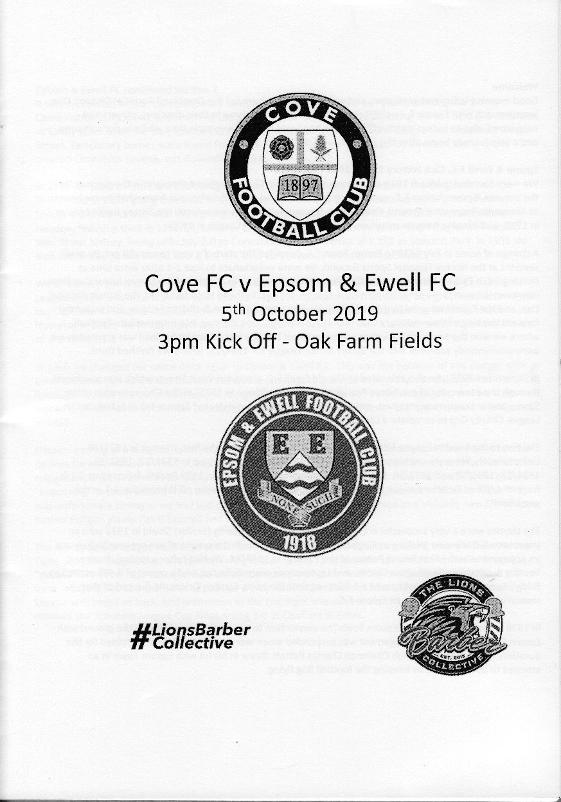
Honours even after late drama

Two goals in injury time ensured that two well-matched teams finished level as Cove threatened to take the points with a late goal, only to see our boys snatch an even later equaliser with Rob Hendry's 93rd minute goal to come away with a 2-2 draw; an entirely fair result.

From a team perspective, we were expecting Chaz-Lee Martin back following the completion of his five match suspension, but he was ill, and Bobby Bennett and Liam Roberts were both working. Throw in Jordan Gallagher's suspension for reaching five bookings and Louis Chin's absence and our Manager's options were a little more limited than they had been recently.

At the back, the Murphy brothers were paired together with Lloyd Connelly out on the right but we were breached as early as the third minute when their striker put the chance wide with Felix Davies standing up well to put him off. Two minutes later we had our first chance as Hendry struck at goal from distance and the ball was spilled by former Hartley Wintney keeper Craig Atkinson, but our strikers were unable to react quickly enough to get to the loose ball in time.

Taryn Smith was next to show and he beat two men before unleashing a low drive that Atkinson blocked with his legs and Sean White then saw his twenty yard effort tipped wide. From the subsequent corner, he had another try from the edge of the box, but Atkinson part saved and part fumbled the ball away for another corner, which regrettably came to nothing.

But the home side were definitely causing problems of their own and in the 23rd minute a long throw was flicked on across our six yard box where fortunately there was no one there to take advantage. However, two minutes later they were ahead after a corner was met by an unmarked header from close range by Louie Chambers, giving Davies no chance.

Within four minutes we were level with arguably the best move of the match. A sweeping move from left to right and initiated by Smith resulted in a square ball to the busy Jake Robinson and his threaded pass to the right was guided into the far corner of the net by Toby Funnell from a narrow angle. This was Funnell's first goal for the club, although he had scored a similar one in a friendly at Horsham under 23s a couple of weeks ago.

We then seemed to lose our composure a bit. Connelly's under hit pass was intercepted by a striker, but fortunately defenders were there to guide him wide from where he only just missed the target with a strike that cleared the bar. Within two minutes Todd Murphy and Davies made a similar error and were indeed fortunate to see the shot go just wide of our goal. Then three minutes before half time they got down the right wing, rounded Joe

Bonass-Ward and sent in a low ball across our goal, but at the far post the golden opportunity was spooned over the bar from no more that ten yards out.

Clearly we were second best at this point although the second half would show a marked improvement. Once Robinson had received treatment for a nasty challenge in the opening minutes, for which Jake Tanner received a yellow card, we started to push for the lead. Smith cut in after a good run and Atkinson tipped over his shot from fifteen yards, and from a deep Funnell cross Darren Turner headed the ball away almost from under his own crossbar. An Adam Heagney shot was not too far wide after good work between Funnell and Hendry and in the 64th minute the ever more influential Robinson made a good run before releasing a reverse pass to White who appeared to have beaten Atkinson, only for the ball to deflect inches wide of the post off his trailing leg.

Heagney was clattered and was subbed, although we went for a more attacking substitution as Zak Nightingale came on and the pressure continued. Smith saw his shot blocked from the edge of the area before Robinson was brought down cynically by the substitute Dean Sumbler who earned another yellow card for the home team and from the subsequent free kick Hendry's delivery was headed away from the incoming Connelly at the last second.

Surely it was a matter of time before we scored, but we were running out of time and in the 90th minute a complete disaster occurred as from Coves first real attack of the half the ball came in from the left and appeared to fall kindly for Lucas Pickett who was able to guide his low shot beyond a possibly unsighted Davies from twelve yards. A fifth defeat in a row was looming large, but to our boys credit they continued to push and Hendry's late equaliser in the 93rd minute gave us the draw.

But should Hendry's 49th goal for the club have stood? It occurred when his corner was fed back out to him, by now around the corner of the penalty area and he decided against crossing it in, instead driving a powerful low shot past Atkinson into the far corner. However, Robinson was clearly in an offside position and had taken a swing at the ball, fortunately failing to make contact. However, when it comes to interference with play these days, just being in the keeper's line of sight is enough for the flag to be risen and his presence certainly distracted the home keeper. As protests followed, you could clearly hear the Assistant say that "he hadn't touched it" but this was irrelevant in this circumstance and the referee made it quite clear that the Assistant hadn't flagged so he wasn't going to disallow it. I think we were a little fortunate to see the goal allowed.

You could argue that this was a little harsh on Cove, but to have lost this match would have also been unfair on our boys. Cove had been the better team in the first half but we had been in the second. Neither team deserved to lose it and if I am being totally honest here, neither team really deserved to win it either as there was little real quality on show, although the grassy, but very uneven playing surface didn't help either set of players. The draw goes in the record books and regrettably it is a further two points dropped in our promotion cause, which looks very precarious as we sit in twelfth place right now and with a testing local derby in Chessington up next.

Epsom and Ewell; Felix Davies, Adam Heagney, Joe Bonass-Ward, Jake Robinson,
Todd Murphy, Lloyd Connelly, Toby Funnell, Scott Murphy(c), Rob Hendry,
Sean White, Taryn Smith

Sub: Zak Nightingale for Heagney (73)

Centre page for results

Centre page for results

FC Deportivo Galicia – History

This Day in History – 19th October
Date | Day | Competition |  | Opponents |  | Scorers
19/10/29 | Sat | F.A. Cup 2q | H | Mitcham Wanderers | 1-0 | J.Parr
19/10/32 | Wed | F.A. Cup 2q replay | H | Nunhead | 5-0 | B.Williams (3), T.Dunne, R.Marlow
19/10/35 | Sat | London League Cup 2 | A | Tilbury | 1-4 | J.Jones (pen)
19/10/46 | Sat | Friendly | A | Barclays Bank | 5-3 | G.Brogdale (3), K.Holliday (2)
19/10/57 | Sat | Corinthian League | H | Maidenhead United | 2-0 | D.Hermitage, J.Bangs
19/10/63 | Sat | Athenian League 1 | A | Wokingham Town | 1-2 | B.Coombs
19/10/68 | Sat | Amateur Cup 2q | A | BAC Weybridge | 2-2 | A.Thompson, A.Parrott (pen)
19/10/74 | Sat | Surrey Senior Cup 2q | H | Nat West Bank | 9-1 | T.Tuite (4), J.Eales (3), D.Ritman, o.g.
19/10/82 | Tue | Isthmian League 1 | A | Lewes | 1-2 | S.Delaney
19/10/85 | Sat | Isthmian League  Premier Division | A | Billericay Town | 0-0
19/10/91 | Sat | Isthmian League 3 | H | Cove | 1-1 | R.Green
19/10/96 | Sat | Isthmian League 3 | H | Braintree Town | 2-5 | A.Boxall (2, 1 pen)
19/10/99 | Tue | Associate Members Trophy 1 | A | Horsham | 6-2 | T.Quinton (3), S.Grant, S.Miller, A.Nimmo
19/10/02 | Sat | Isthmian League 1s | A | Croydon Athletic | 1-1 | J.Hall
19/10/10 | Tue | Combined Counties Premier Division | H | Ash United | 1-1 | o.g.
19/10/13 | Sat | Combined Counties Premier Division | H | Frimley Green | 3-0 | M.Jarman, K.Douglin, A.McGregor
Historical Decades
Date | Day | Competition |  | Opponents |  | Scorers
100 years ago – Epsom Juniors F.C.
18/10/19 | Sat | Surrey Junior Cup 1 | A | Belmont | 0-2
90 years ago – Epsom Town F.C.
19/10/29 | Sat | F.A. Cup 2q | H | Mitcham Wanderers | 1-0 | J.Parr
70 years ago – Epsom F.C.
15/10/49 | Sat | F.A. Cup 2q | H | Kingstonian | 1-3 | B.Cutter
60 years ago – Epsom F.C.
17/10/59 | Sat | Surrey Senior Cup 2q | H | Worcester Park | 2-0 | S.Law, F.Vernon
50 years ago – Epsom & Ewell F.C.
18/10/69 | Sat | Amateur Cup 1q 3 replay | A | Whitehawk | 1-0 | D.Morrish
40 years ago – Epsom & Ewell F.C.
20/10/79 | Sat | London Senior Cup 1q | A | Beckenham Town | 2-0 | R.Lewis, D.Walker
30 years ago – Epsom & Ewell F.C.
21/10/89 | Sat | Isthmian League 2s | H | Ruislip Manor | 0-5
20 years ago – Epsom & Ewell F.C.
19/10/99 | Tue | Associate Members Trophy 1 | A | Horsham | 6-2 | T.Quinton (3), S.Grant, S.Miller, A.Nimmo
10 years ago – Epsom & Ewell F.C.
20/10/09 | Tue | Combined Counties League Cup 2 | A | North Greenford United | 0-1
History Corner – 19th October
100 years ago this week we made our debut in the Surrey Junior Cup; a competition we would reach the Final of three seasons later, but we were a very young team at this point and two second half goals consigned us to defeat at Belmont, whose official ground back then was “up on the Banstead Downs”. As long as both teams knew where it was, I suppose it was ok!

90 years ago today we defeated local rivals Mitcham Wanderers by a goal to nil in the F.A. Cup at West Street with Jack Parr scoring the winner. He had been amongst the scorers when we had knocked them out of the same competition two years previously, but this was a bigger second qualifying round match and earned us the “honour” of a trip to Wimbledon before crashing out 7-1 at Plough Lane in front of just under 7,500 spectators. Hard to believe now, isn’t it!

87 years ago today we destroyed Isthmian League Nunhead by five clear goals in a midweek F.A. Cup replay at West Street. The Nuns had been Isthmian League Champions just two years previously and we had held them to a goalless draw on the Saturday, but on the Wednesday Billy Williams scored a hat trick while Tommy Dunne and Reg Marlow got the others. Regrettably the run would end the following round with a 3-1 defeat at Met Police who would also knock us out of the Amateur Cup, but they were a decent side who had reached the Quarter-Finals of the Amateur Cup in 1931 themselves, so it was no disgrace.

73 years ago today we defeated Barclays Bank’s work side 5-3 in a friendly at West Street with Gordon Brogdale scoring three times and Ken Holliday getting the other two.

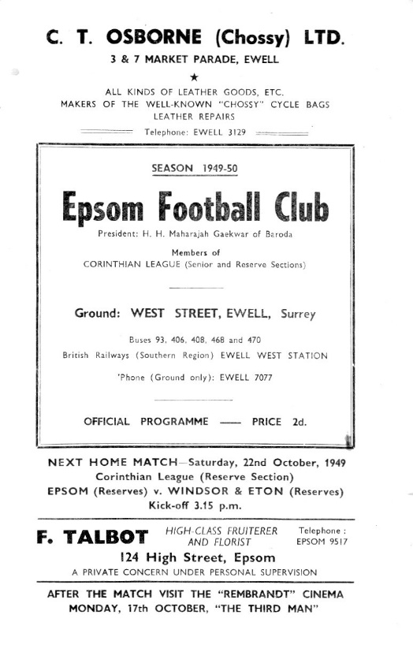
70 years ago this week we were at home to Kingstonian in the F.A. Cup, being defeated by three goals to one. This match produced a post war attendance record of 5,000 people at West Street and without any concrete figures to support evidence of larger attendances pre-war, this remained our largest official attendance at West Street. (see programme pictured)

50 years ago this week the Amateur Cup Quadrilogy ended! We defeated Whitehawk 1-0 in Brighton in a third replay after draws at home and away as well as at Horsham’s old Queen Street ground. Dave Morrish scored our goal but we were then knocked out by a Chris Kelly inspired Tooting & Mitcham United in the next round anyway!

35 years ago today we battered the Nat West Bank in a Surrey Senior Cup tie by nine goals to one at West Street. Tommy Tuite scored four of those goals while Johnny Eales also scored a hat trick against our woefully outclassed visitors.

20 years ago today we visited Horsham’s old Queen Street ground and crushed them 6-2 in an Associate Members Trophy match with Tony Quinton scoring his one hat trick for the club before his move up to the higher reaches of the non-league football pyramid. It was the last time we would ever win there.

100 years ago this month
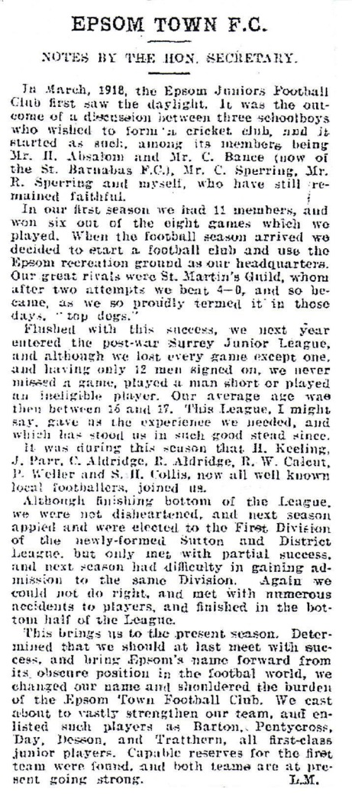
Just over 18 months ago we marked our club Centenary, so why, you might be asking, am I going on about this now? It’s a straightforward explanation, but I shall provide the answer by way of some background history too!

Epsom Juniors were founded in March of 1918. For around ninety of those hundred years, the club had been advertising its foundation date as 1917, but some thorough research enabled me to uncover the truth.

In the report pictured here and taken from the long departed Sutton & Epsom Illustrated Mail, our Secretary at the time, Len Miller, wrote in with a report of our early days as a club.

Indeed, as you can see from the report, we were founded as a cricket club to play throughout the summer of 1918. Once the warm season concluded, it made sense for the players to extend their interests into the world of football.

We played friendlies through 1918/19, although none were reported in the papers. There is a reference in this attached report to a St Martin’s Guild and this almost certainly refers to the pre-war Epsom St Martin’s, who, along with Epsom Athletic contested the honours in a town without a senior football club. Athletic failed to

reform after the war, although did reappear for a few years in the 1920s, while St Martins clearly did reform but didn’t survive for long.

Of course, it would be some six years before we would finally have a team of Senior Status, not being elected to the Surrey Senior League until 1924, but as the 1918/19 season concluded, Miller felt confident enough to assert that the Epsom Juniors were the top club in Epsom; not a particularly great achievement at the time, but I suppose you can only beat whoever is in front of you!

We reverted to cricket in the summer of 1919 and here is where the first report of our club appears, playing against Epsom Corinthians in a cricket match on 14th June 1919. From Miller’s report it is not exactly a leap of faith to conclude that we didn’t have a large pool of players to choose from, as he reports that we only had twelve players signed on, yet never played a man short. From this, it is a reasonable assumption that the cricket line up would have been very close to the team that was playing football for us in those formative years.

Our line-up that day read: Reg Sperring, Len Miller, Harold Keeling, F.Jaycocks, Ernie Sperring, Stan Collis, Reg Aldridge, F.Stuart, E.Johns, Jack Parr, Charlie Aldridge. In the match we were all out for 77 and then for 40, yet still won by 38 runs as the opposition was bowled out for 41 and 38!!

One or two of our players, most notably Jack Parr went on to play for Epsom Rovers, the second team in Epsom behind the main Epsom Cricket Club, but as the summer concluded, we found ourselves back in the football season.

The month of August used to be exclusively a cricket month back then, with September being used for football only by the professional teams. By October of 1919 with the world at peace once again following the November 1918 Armistice, the football leagues were reforming. Powerful leagues like the Southern and the Isthmian League kicked off again in the autumn, although the latter had run an emergency competition for five of its clubs from January of 1919. Further down the list, the Athenian League and Spartan League continued where they left off, while one of the main leagues in our catchment area, the Southern Suburban League, was a big pull for local clubs, although its demise would be sealed by the emergence of the Surrey Senior League in 1922.

Lower down still was the Surrey Junior League; a competition that had existed since the 1890s and had been entered by earlier incarnations of the Epsom club in 1905/06, 1907/08 and from 1909/11 with no success of any kind whatsoever, finishing at the foot of the table in three of those four seasons, with a third from bottom position being the highlight of our success in 1907/08. Frankly, Epsom was exclusively a racing town and players from this area who outgrew their level like Harry Skinner and Arthur Holt, found themselves playing for larger clubs further afield, most notably West Norwood in the Isthmian League.

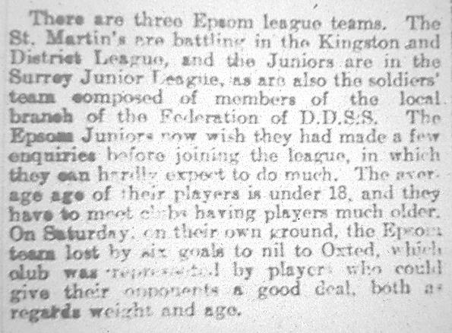
Anyway, I digress! The Surrey Junior League reformed for 1919/20 and the Epsom Juniors joined up, playing their first ever competitive match on 4th October 1919 against Oxted. It did not go well! (see report left)

Clearly our boys had bitten off more than they could chew. It is worth noting that founder members, the twins Reg and Ernie Sperring were actually playing this match on their sixteenth birthdays! We were a very young side, which also explains the reasoning behind the name “Epsom Juniors”, which would be changed to Epsom Town in 1922. It really was a team of kids!

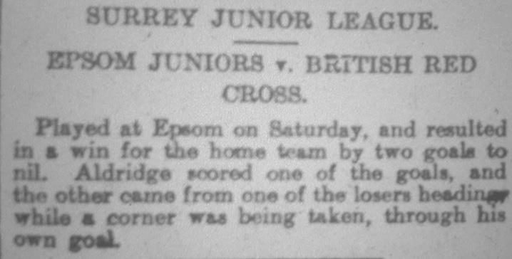
Needless to say, the season was to prove a difficult one, with a heavy defeat following at North Croydon seven days later (see left) and with only one win recorded during the whole league season, against the British Red Cross on 22nd November 1919 when we defeated them at Alexandra Recreation Ground, then known as Epsom Recreation Ground, by two goals to nil. Unfortunately, the Red Cross failed to complete their league fixtures and we then finished bottom, which in fairness was no worse than the pre-war clubs had achieved!

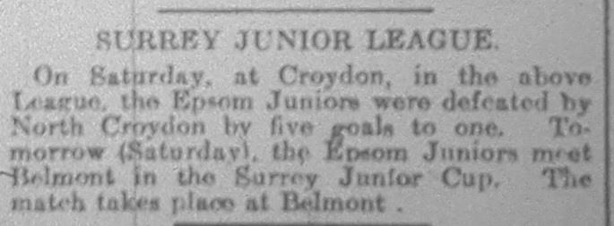
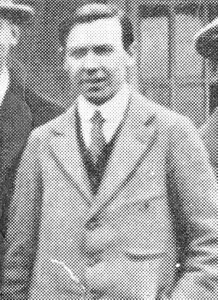
Fortunately, a visionary gentleman was about to enter the proceedings. His name was Hugh Cyril Bradley (pictured left) and as a Secretary of the Old Suttonians football club, he felt that there was the need for a new football league in the area. Together with Jack Goossens, Chairman of Sutton United at the time, the Sutton and District League was founded in August of 1920 and the Epsom Juniors became founder members. Two years later after Bradley had issued a plea for a unified and representative team in Epsom, he would get no interest from the Epsom Brotherhood team, but plenty of interest from the Juniors who would change their name and appoint him as Chairman. The good times were about to start for our club, with a Sutton & District League title in 1922/23, the Southern Suburban League title in 1923/24 and then unanimous election to the Surrey Senior League in 1924 with a League title in 1925/26 and a League and Cup double the following season. Throw in a new ground at West Street in 1925 and a

further league triumph as the London League title came our way in 1928 and you will see that these were halcyon days for our club. Bradley left the area in 1928 and to my knowledge never returned, while our benefactor Robert Bradshaw (who paid for the ground) died in the same year, but we were set for many years as a result and still exist as the club you know and follow today.

There is one final question to clear up which relates to why the club said it was founded in 1917. Even nine years later in a January 1926 programme it was stating this as the formation date, despite many people still being involved with the club who would have known, like Miller, that the club were founded a year later. I have just one theory. As a new club, they wanted to be seen as having been in existence for longer, and employing a little journalistic licence, they advised their formation as the 1917/18 season, which technically it was. This then got shortened to 1917, despite probably never even discussing the sport at any point until the year after!

I should just conclude by advising that Len Miller lived at “Ivanhoe” in Chase Road, Epsom in the early twenties, yet by the fifties, it was being lived in by another Epsom legend, Ernie Watkins. His daughter Mary Beadle still lives there today and the property is one door along from the Italian delicatessen on the corner of Chase Road and Hook Road. Small world eh!!

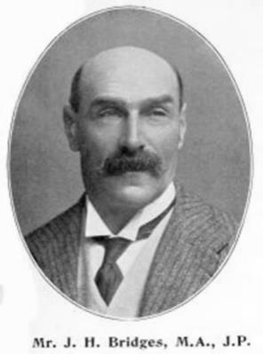
It is also worth relating another milestone, as 135 years ago this month the first football in Epsom actually took place!

Some regular supporters will have recalled my stories in the past of Ewell FC, who were the first club to use West Street and would go on to reach both the Surrey Charity Shield Final and the Surrey Senior Cup Final in 1898 and 1899 respectively before the Boer War affected the availability and number of players, with the club folding in 1905. They had been founded by John Henry Bridges together with a couple of rather warm football players, Arthur Melmoth Walters and Percy Melmoth Walters, who became better known as Morning and Afternoon due to their initials! (Arthur is left below)

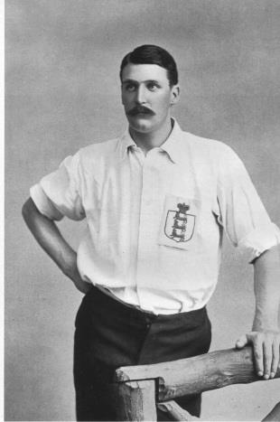
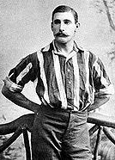
These two were not just good, they were very good. Both of them were regular England FULL International players, with Percy Captaining the team on a few occasions. They lived in Ewell Village and just wanted to form a team!

However, there was football in the town some six years before that. Back on 11th October 1884 a trial match was arranged at a site close to the Epsom Workhouse, which is now covered by Epsom Hospital. Whilst it is not clear how much these two players had to do with it, they definitely played in some of the matches back then. In fact 1884/85 was a massive year for the pair as they would reach the FA Cup Quarter-Finals with the Old Carthusians as well as making their England debuts against Ireland on 28th February 1885. One month later they were both playing for the new Epsom team against Weybridge!

Player Sponsorship
Here is the new list of players for 2019/20, with photos showing all of our boys and also our Management team that are available for sponsorship. Thanks as always to our Club Photographer Gemma Jarman.

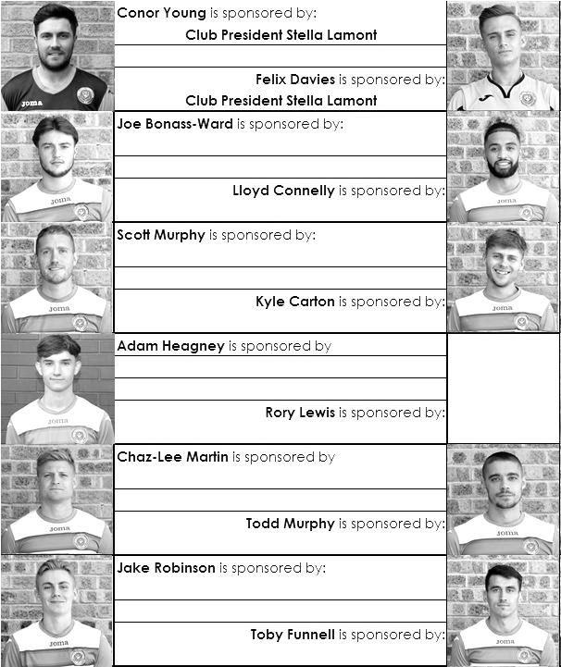

Sponsorship costs just £40 and it is easy to do. Just select a player who has not been previously sponsored and let a Committee Member know that you would like to sponsor them. Beware though. Until we have received the money it is possible for someone to jump in front of you, so don’t delay, sponsor today!

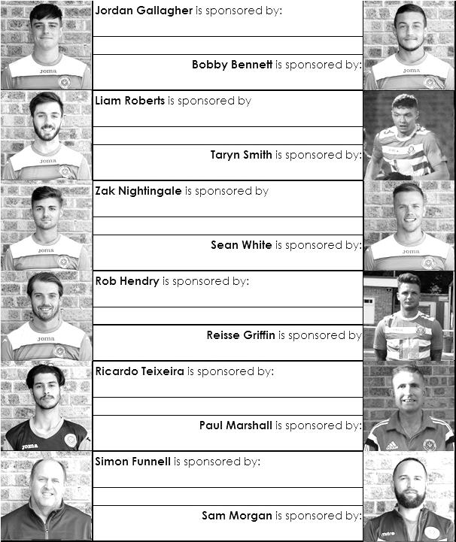

CCL Division One Club Directory
AFC HAYES: Telephone: 0208 845 0110 - Colours: Blue and White Stripes/Blue/Blue
Ground: Farm Park, Kingshill Avenue, Hayes, Middx. UB4 8DD

ASH UNITED: Telephone: 01252 344264 - Colours: Green with Red Trim/Green/Green
Ground: Shawfields Stadium, Youngs Drive, Shawfields Road, Ash, Aldershot. GU12 6RE

BAGSHOT: Telephone: 01252 623804 - Colours: Yellow/Black/Black
Ground: Camberley Town FC – Krooner Park, Wilton Road, Camberley. GU15 2QW

BEDFONT & FELTHAM: Telephone: 0208-890 7264 - Colours: Yellow/Blue/Blue
Ground: The Orchard, Hatton Road, Bedfont. TW14 9QT

BRITISH AIRWAYS: Telephone: 0208-890 7264 - Colours: Sky Blue/Navy Blue/Navy Blue
Ground: Bedfont & Feltham FC - The Orchard, Hatton Road, Bedfont. TW14 9QT

CHESSINGTON & HOOK UNITED: Telephone: 01372-602263 Colours: All Blue
Ground: Chalky Lane, Chessington. KT9 2NF

COVE: Telephone: 01252 543615 Colours: Yellow/Black/Black
Ground: Oak Farm, Squirrel Lane, Cove GU14 8PB

DORKING WANDERERS RES Telephone: 01306 400151 - Colours: Red & White Stripes/ Blue/ Red
Ground: Meadowbank Stadium, Mill Lane, Dorking. RH4 1DX

EPSOM & EWELL Telephone: 01737-553250
Colours: Royal Blue & White Hoops/Royal Blue/Royal Blue
Ground: Chipstead FC, High Road, Chipstead. CR5 3SF

EVERSLEY & CALIFORNIA Telephone: 0118 973 2400 - Colours: - White & Royal Blue Hoops /Royal Blue/ Royal Blue - Ground: Fox Lane, off Reading Road, Eversley. RG27 0NS

FARNHAM TOWN Telephone: 01252 715305 - Colours: - Claret & Sky Blue /White/ Claret & Blue
Ground: Memorial Ground, Babbs Mead, West Street, Farnham. GU9 7DY

FC DEPORTIVO GALICIA Telephone: 0208 831 9067 - Colours: Royal Blue/Royal Blue/White
Ground: Bedfont Sports FC - Bedfont Sports Club, Hatton Road, Bedfont. TW14 9JR

FLEET SPURS Telephone: 01252 662810 - Colours: Dark Blue with Red Trim/Dark Blue/Dark Blue
Ground: Kennels Lane Farnborough. GU14 0ST

GODALMING TOWN Telephone: 01483 417520 - Colours: Yellow/Green/Yellow
Ground: Wey Court, Meadrow, Godalming. GU7 3JE

JERSEY BULLS Telephone: 01534 449615 - Colours: Red and White
Ground: Springfield Stadium, Janvrin Road, St Helier, Jersey. JE2 4LF

KENSINGTON & EALING BOROUGH Telephone: 01372 360151 - Colours: All Blue
Ground: Leatherhead FC – Fetcham Grove, Guildford Road, Leatherhead. KT22 9AS

SANDHURST TOWN Telephone: 01252 878768 - Colours: Red & Black Stripes/Black/Black
Ground: Bottom Meadow, Sandhurst Memorial Park, Yorktown Road, Sandhurst. GU47 9BJ

TOOTING BEC Telephone: tba - Colours: Black & White Stripes/White/White & Black
Ground: Tooting & Mitcham United FC - Imperial Fields, Bishopsford Road, Morden, Surrey SM4 6BF

WALTON & HERSHAM Telephone: 07969 068731 - Colours: All Red
Ground: Elmbridge Excel Sports Hub, Waterside Drive, Walton-on-Thames. KT12 2JP

WESTSIDE Telephone: 01372-602263 - Colours: Yellow/Blue/Blue
Ground: Chessington & Hook United - Chalky Lane, Chessington. KT9 2NF

Results Grid
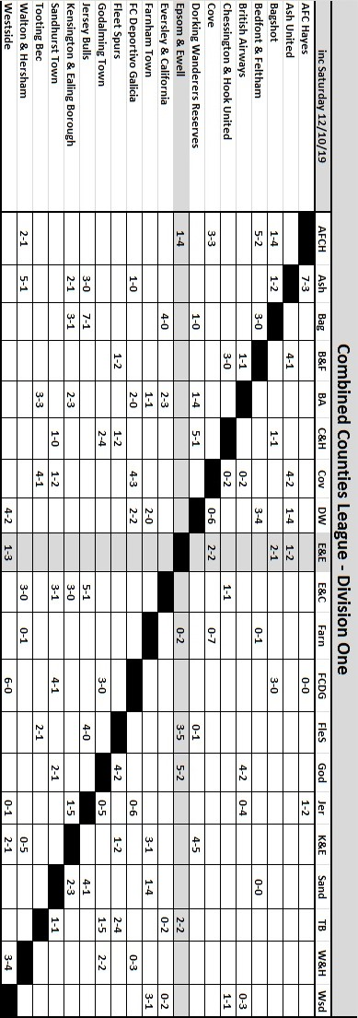

Match and Ball Sponsorships – 2019/20
Opponent | Date | Match Sponsor | Ball Sponsor
Fleet Spurs | 03/08/19 | Club President - Stella Lamont
Godalming Town | 20/09/19 | Paul Merritt
Tooting Bec | 27/09/19 | EEFC Management Committee
Kennington (FA Vase) | 31/08/19 | Geoff Dyke – celebrating his 70th birthday
AFC Hayes | 21/09/19 | Philip Harris
Farnham Town | 28/09/19 | Paul Marshall
FC Deportivo Galicia | 19/10/19
Kensington & Ealing Borough | 26/10/19
Sandhurst Town | 09/11/19
Dorking Wanderers Res | 23/11/19
Bedfont & Feltham | 14/12/19
Westside | 28/12/19
British Airways | 11/01/20
Cove | 25/01/20
Ash United | 08/02/20
Chessington & Hook United | 22/02/20
Eversley & California | 21/03/20
Walton & Hersham | 31/03/20 | Tony Foster
Bagshot | 04/04/20 | Nathan Lambert
Jersey Bulls | 13/04/20
Match sponsorship costs just £60.00!

Sponsorship includes:

Admission, programmes and hospitality for three people.

A full page advert in the programme and mascot for the day (if required).

Also, you get to choose the player of the match, who will receive a prize

If you are interested, just speak to a Committee Member,
or drop me an email at: richard.c.lambert@gmail.com

Combined Counties League Division One
Opponents All-time Records
inc 5th October 2019 | P | W | D | L | F | A | PPG | GD | Best  Win | Worst  Loss
Westside | 1 | 1 | 0 | 0 | 3 | 1 | 3.00 | +2 | 3-1 | -
Bedfont & Feltham | 5 | 4 | 1 | 0 | 25 | 12 | 2.67 | +13 | 9-2 | -
Godalming Town | 7 | 6 | 0 | 1 | 20 | 11 | 2.57 | +9 | 5-1 | 0-3
Bagshot | 4 | 3 | 0 | 1 | 12 | 3 | 2.25 | +9 | 7-1 | 1-2
FC Deportivo Galicia | 3 | 2 | 0 | 1 | 7 | 4 | 2.00 | +4 | 3-0 | 0-2
Ash United | 22 | 12 | 4 | 6 | 52 | 33 | 1.82 | +19 | 6-0 | 0-3
Cove | 37 | 17 | 10 | 10 | 82 | 60 | 1.65 | +22 | 7-0 | 1-6
Chessington & Hook | 30 | 13 | 9 | 8 | 63 | 45 | 1.60 | +18 | 6-0 | 1-3
Walton & Hersham | 54 | 25 | 11 | 18 | 105 | 105 | 1.59 | 0 | 8-0 | 0-8
Farnham Town | 20 | 9 | 4 | 7 | 32 | 33 | 1.55 | -1 | 3-0 | 1-4
Dorking Wanderers Res | 2 | 1 | 0 | 1 | 6 | 5 | 1.50 | +1 | 3-0 | 3-5
British Airways | 2 | 1 | 0 | 1 | 5 | 5 | 1.50 | 0 | 3-2 | 2-3
Eversley & California | 2 | 1 | 0 | 1 | 2 | 2 | 1.50 | 0 | 1-0 | 1-2
Fleet Spurs | 3 | 1 | 1 | 1 | 7 | 8 | 1.33 | -1 | 3-2 | 3-5
Tooting Bec | 3 | 1 | 1 | 1 | 6 | 7 | 1.33 | -1 | 3-1 | 1-4
Sandhurst Town | 17 | 7 | 0 | 10 | 29 | 31 | 1.24 | -2 | 4-0 | 1-3
AFC Hayes  (inc Brook House) | 13 | 2 | 4 | 7 | 19 | 24 | 0.77 | -5 | 7-0 | 1-4
Kensington Borough | 2 | 0 | 1 | 1 | 2 | 6 | 0.50 | -4 | - | 1-5
Jersey Bulls | 0 | 0 | 0 | 0 | 0 | 0 | - | 0 | - | -

Combined Counties League – Division One
Saturday, 19th October 2019 - Kick-off 3.00 p.m.
Epsom and Ewell  (Royal Blue & White hoops) | V |  | FC Deportivo Galicia  (Red / Green / Red)
Squad | NUMBERS |  | Squad
Felix Davies |  |  | Dani Diaz
Conor Young |  |  | Ali Soussi
Reisse Griffin |  |  | Ahmed El Hanna
Adam Heagney |  |  | Mohammed Cisse
Lloyd Connelly |  |  | Razzy Nadeem
Chris Head |  |  | Leo Carvalho
Chaz-Lee Martin |  |  | Helder Lopes
Joe Bonass-Ward |  |  | Anton Fernandez
Todd Murphy |  |  | Julian Lorenzo
© Scott Murphy |  |  | Felipe Nogaledo ©
Sean White |  |  | Xavi Perez
Bobby Bennett |  |  | Beto Miras
Jake Robinson |  |  | Bruno Martinho
Rory Lewis |  |  | Dean Simms
Ashley Thompson |  |  | Jason Lozano
Rob Hendry
Taryn Smith
Toby Funnell
Jordan Gallagher
Liam Roberts
Ricardo Teixeira
Simon Funnell | MANAGER |  | Leo Decabo
Sam Morgan / Paul Marshall | ASSISTANTS
Sam Morgan | COACHES |  | Jose Andon
 | PHYSIO |  | Murat Muftuoglu
REFEREE: E.Makola
ASSISTANTS: D.Vernon, to be advised

OUR NEXT VISITORS TO HIGH ROAD
Sandhurst Town
Combined Counties League – Division One
Saturday, 9th November 2019 – Kick-off – 3.00 p.m.

